Univerzitet u Sarajevu

Elektrotehnički fakultet Sarajevo

Odsjek za računarstvo i informatiku

Instructions Documentation (*User Guide*)

Embeded systems

Name and surname: *Nejla Subašić*

Index number: *18620*

Name and surname: *Matej Marinčić*

Index number: *18729*

User (*documentacion*) guide

Our app is developed on an online simulator [**mbed.webredirect.org**](http://mbed.webredirect.org/)**, it is very easy to use, so we will take you step by step and explain how to use our app in order to have the best possible experience!**

**When you enter the link above, you will see something like this (*picture below*)**

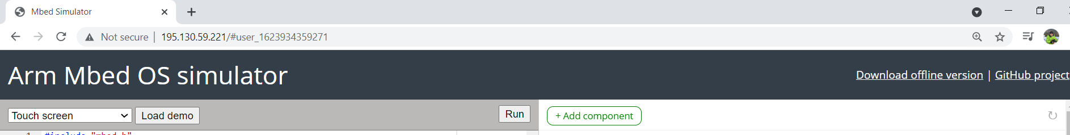

In order to start our app (*game*), you simply click on the “Run” button.

We have developed our app to be very simple to use, It only depends on touch screen, so it will be easy to use even for young children.

When you press the “Run” button, the following screen will appear.

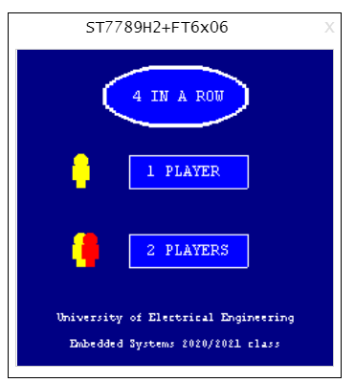

On this screen you have 2 choices to pick from. If you like to play alone (*you VS computer*), you simply press the “1 Player” box, on the other hand if you want to play with a friend, of course you choose the “2 Players” box.

If you choose the single player mode, you will play against our automated “bot”. You will be the first player and your color is yellow, the bots color is red.

The following picture shows the screen for your single player mode:

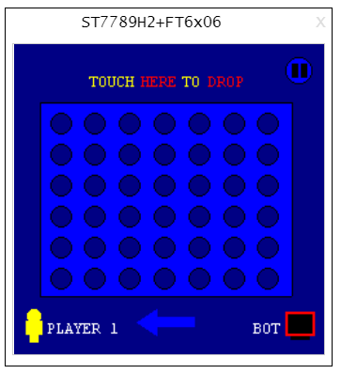

This is you. And this is your opponent (*bot*).

You play first, the goal of the game is to get 4 of your yellow pieces in a row (horizontally, vertically or diagonally). You can touch the screen wherever you want, but when you want to put a coin in, you must **touch above the bar**, like in real life when you put it in. For example if we want to put a coin here , you need to press here (right above the column).



When you press it, it will trigger a “coin fall animation” and your coin will settle in the last available spot, like this:

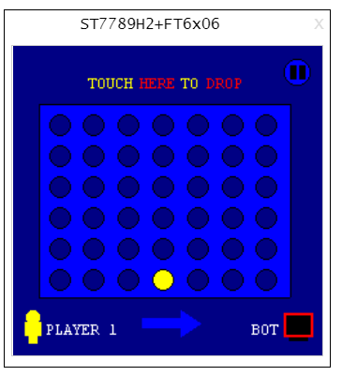

When you or the bot win, we will congratulate with this screen:

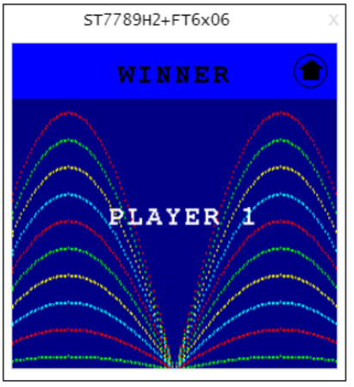

If you want to play again or just want to exit our app, just press on the “Home icon”.

If you choose our second option “2 Players”, you will get this screen:

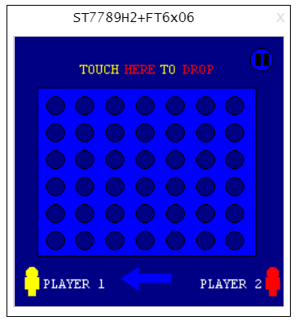

Player 1, gets the yellow coins, the second player gets the red ones.

This arrow will dynamically change, so it will always point to the player that has the next move. The rules of the game and the way to play is the same as already shown.

So if you make the first move, the screen will show you this:

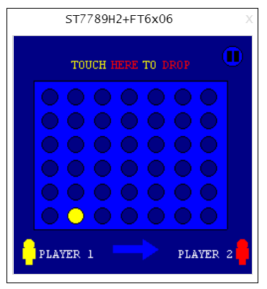

As you can see the arrow is now pointing to the second player and waiting for his move.

If you want to catch a break, restart the game or exit to home screen, you can press the “pause button”

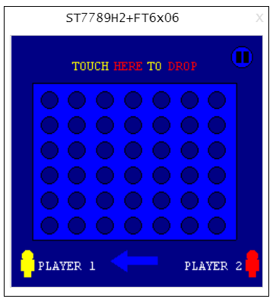

By pressing that button you will see the following:

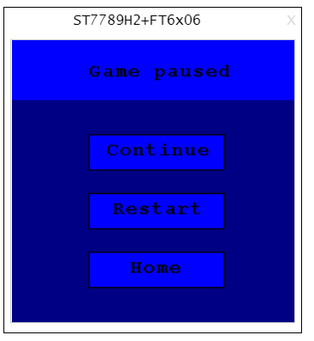

By pressing “Continue” you will resume your previously paused game. If you press “Restart”, that will start a new game (*whether a single player or a 2 player mode*). Lastly by pressing the “Home” you will be taken back to the already shown home screen.

We hope you now understand how to fully use our interesting and fun app, enjoy!